Lab 5

- Show all steps of In-Place QuickSort in sorting the array [1, 6, 2, 4, 3, 5] when doing first partition. Use leftmost values as pivots.
Solution:

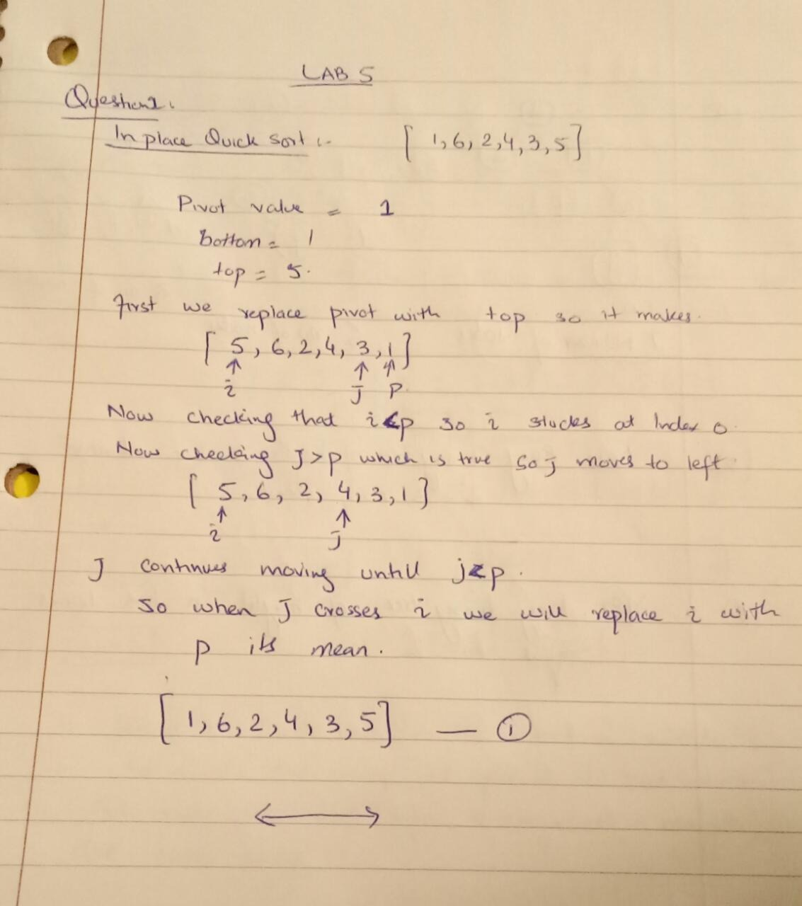

- In our average case analysis of QuickSort, we defined a good self-call to be one in which the pivot x is chosen so that number of elements < x is less than 3n/4, and also the number of elements > x is less than 3n/4. We call an x with these properties a good pivot. When n is a power of 2, it is not hard to see that at least half of the elements in an n-element array could be used as a good pivot (exactly half if there are no duplicates). For this exercise, you will verify this property for the array A = [5, 1, 4, 3, 6, 2, 7, 1, 3] (here, n = 9). Note: For this analysis, use the version of QuickSort in which partitioning produces 3 subsequences L, E, R of the input sequence S.
  - Which x in A are good pivots? In other words, which values x in A satisfy:
    - the number of elements < x is less than 3n/4, and also
    - the number of elements > x is less than 3n/4
  - Is it true that at least half the elements of A are good pivots?
Solution:
So here n=9
So according to formula,
The number of L and R must be less than (3*9)/4=6.75
- If we apply median to choose Pivot
Median=5
So we choose 5 as the pivot point. If we choose 5 as Pivot value
L={1,2,3,2,1,3} =6<6.75
E={5}
G={6,7}=2<6.75
Pivot = 5 : L = {1,4,3,2,1,3} = 6 <6.75; E ={5} = 1 ; G = {6,7}= 2 <6.75
Pivot = 4 : L = {1,3,2,1,3} = 5 <6.75; E ={4} = 1 ; G = {5,6,7}= 3 <6.75
Pivot = 3 : L = {1 ,2,1} =3 <6.75 : E = {3,3}= 2 ; G = {4,5,6,7}=4 <6.75
Pivot = 2 : L = {1 , 1} =2 <6.75 : E = {2}= 1 ; G = {3,3,4,65,7}=6 <6.75
Good pivots = {5,4,3,3,2}
As L and G are less than 6.75 so 5 is a good Pivot point.

- Solution:
As there are 9 number of elements which is not a power of 2 so there must be at least half the elements of A are good pivot.

- Interview Question. Give an o(n) (“little-oh”) algorithm for determining whether a sorted array A of distinct integers contains an element m for which A[m] = m. You must also provide a proof that your algorithm runs in o(n) time.

Solution:
Algorithm:
If(high>=low) then
mid←(low+high)/2
if(mid==arr[mid]) then
return mid
if(mid>arr[mid]) then
return binarysearch(arr,mid+1,high)
if(mid<arr[mid]) then
return binarysearch(arr,low,mid-1)
return -1
According to this algorithm it will run O(logn) times to execute this. As the Sequence does,nt iterate n times and because f(n ) = logn ; g(n ) = n . f(n ) < g(n ) . So, f(n ) is o(n )

- Prove the following recursive factorial algorithm is correct.

Algorithm recursiveFactorial(n) Input: A non-negative integer n Output: n!

if (n = 0 || n = 1) then return 1

return n * recursiveFactorial(n-1)

Solution:

Solution: 3 steps to prove
1. Valid recursion: because when n=0, or n=1. The self-call lead to base case
2. Base case corrects: 1! = 1 = 1.1 = 1 * F(0) is true with base case
3. Recursive step correct: Assume the recursive Factorial(n-1) is correct: F(n-1)= (n-1)! = (n-1 ) * (n-2)! =(n-1) *F(n-2) Prove recursive Factorial(n) is correct: n! = n*(n-1)! = n*(n-1)*(n-2)! =n*F(n-1) true

- Review of SubsetSum Problem: Given a set S = {s0, s1,s2, …, sn-1} of positive integers and a non-negative integer k, find a subset T of S so that the sum of the integers in T equals k or indicate no such subset can be found.

We have already seen a brute force solution to this problem in an earlier lab. In this exercise, you are going to come up with a recursive solution for SubsetSum. Write the pseudo code for your algorithm.

Hint:

Solution:

Algorithm SubsetSum(S,K)

Input: S={so,s1,s2,s3,…..,sn-1} positive integers, K is also a non negative integer
Output: T which is a subset of Set S whose sum is equal to K
//Base Case
If(s.size==1) then

if k=0 then return {}
else if k=s0 then return {s0}
else return NULL
(S,last) ←S.removelast()
T←SubsetSum(S,K)
If T not NULL then
return T
T← SubsetSum(S,K-last)
If T not NULL then
return TU(last)
return NULL
